COFFEE SHOP SALES ANALYSIS DASHBOARD USING POWER BI – WEEK 2

Submitted By: Jonnalagadda Venkata Naga Vishnusri

Internship: Virtual Power BI Data Visualization Internship

Organization: Henry Harvin Education in collaboration with YuvaIntern

Dataset: Coffee Shop Sales Dataset (Maven Analytics)

Submission Date: 06 August 2026

Project Title: Coffee Shop Sales Analysis Dashboard using Power BI – Week 2
Table of Contents:
- Introduction
- Objective
- Dataset Description
- Data Preparation
- Data Modeling
- DAX Measures
- Screenshots
- Conclusion

- Introduction:
This report prevents the second phase of the Coffee Shop Sales Analysis project using Microsoft Power BI. The focus of this week is on preparing the dataset, verifying data quality, creating data models, and implementing DAX measures for the business analysis.

- Project Objectives:
- Import the Dataset into Power BI.
- Verify and Clean the Data.
- Prepare the Data Model.
- Create DAX Measures.
- Understand business metrics using Power BI.

- Data Description:
The Coffee Shop Sales Dataset contains transactional information including:
- Transaction Id
- Transaction Date
- Store Location
- Product Category
- Product Type
- Quantity Sold
- Unit Price
- Total Sales
This Dataset is used to analyze sales performance and business insights.
- Data Preparation:
The following preprocessing steps were completed:
- Imported the Excel dataset into Power BI.
- Verifying the Data Types.
- Checked for Missing Values.
- Confirmed Data Format.
- Validated Numerical Columns.
- Data Modeling:
Since this project uses a single dataset table, no table relationships were required. The data model was verified to ensure that all columns were correctly recognized for analysis.
- DAX Measures:
- Total Sales.
- Total Orders.
- Total Quantity sold.
- Average Order Value.
- Average Selling Price.
- Screenshots:
Insertion of the Screenshots of:
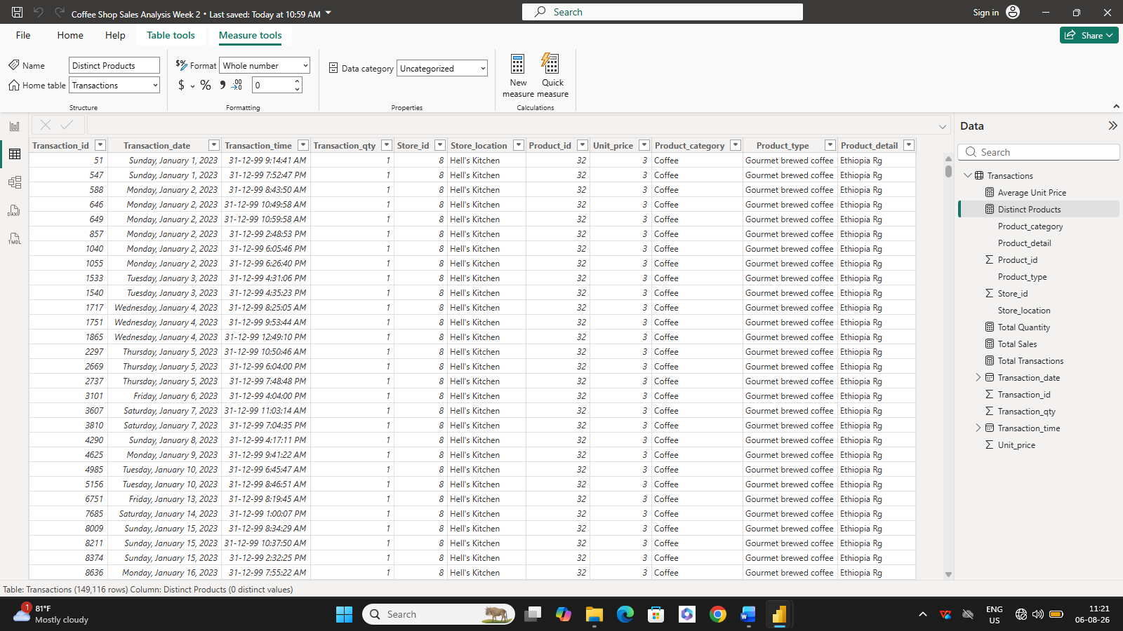
- Data View

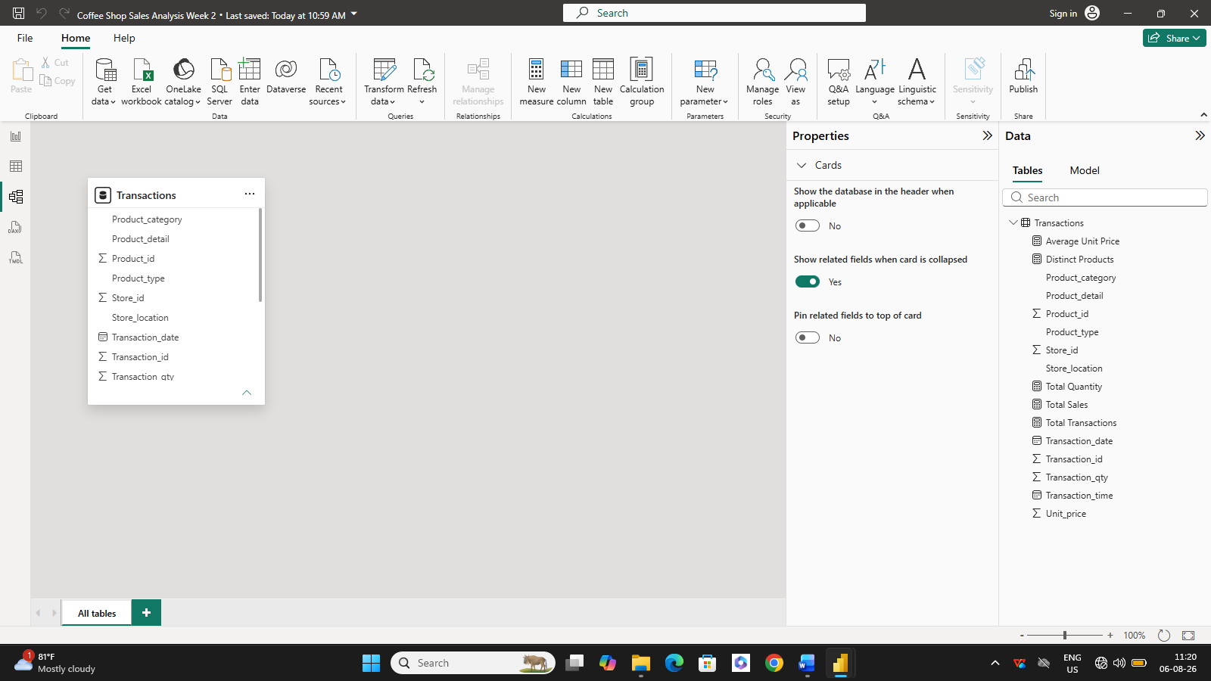
- Model View

- DAX Measures
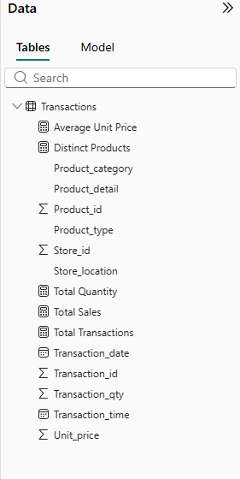

- Formula Bar
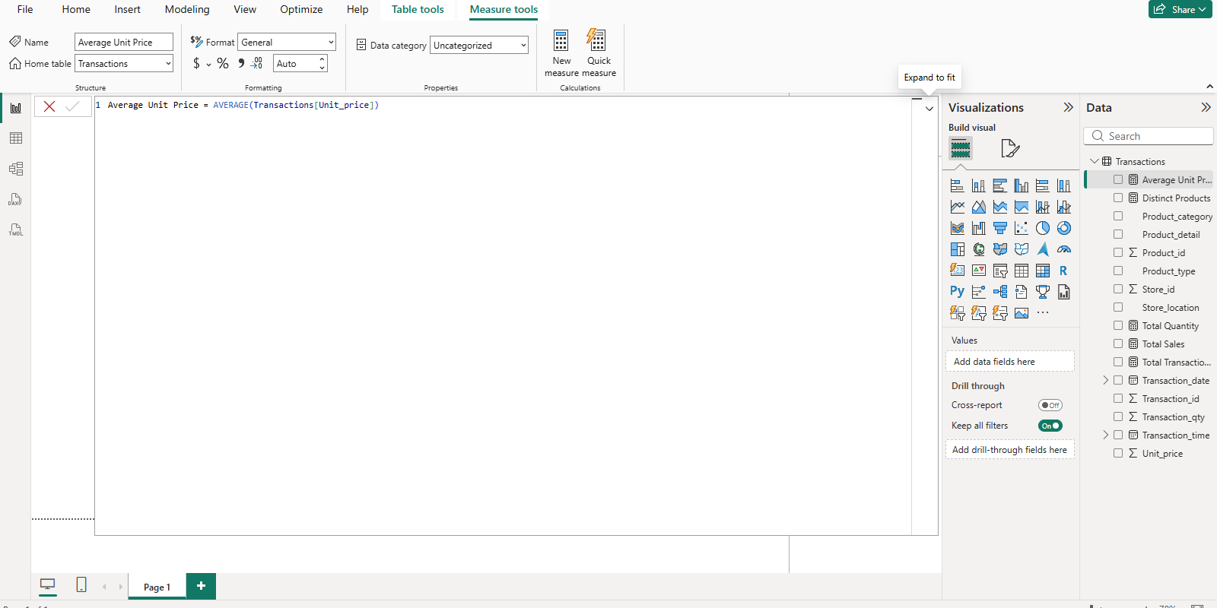

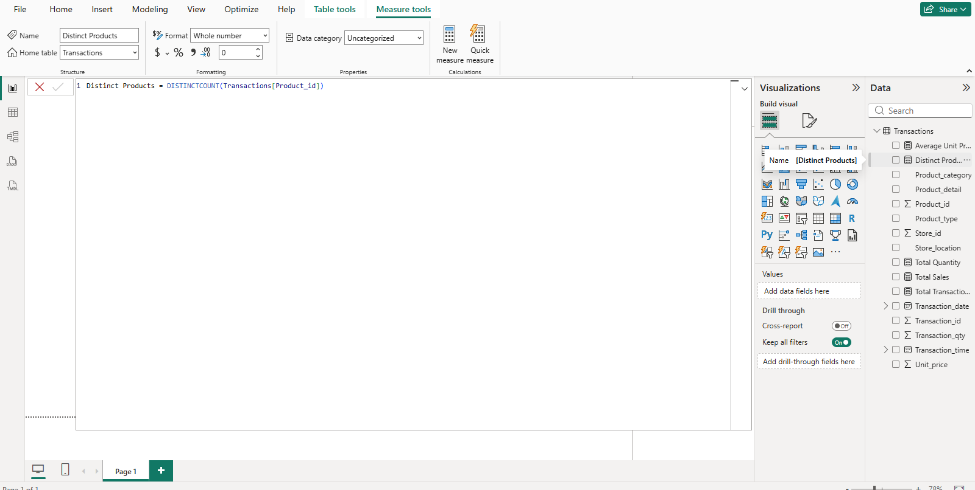

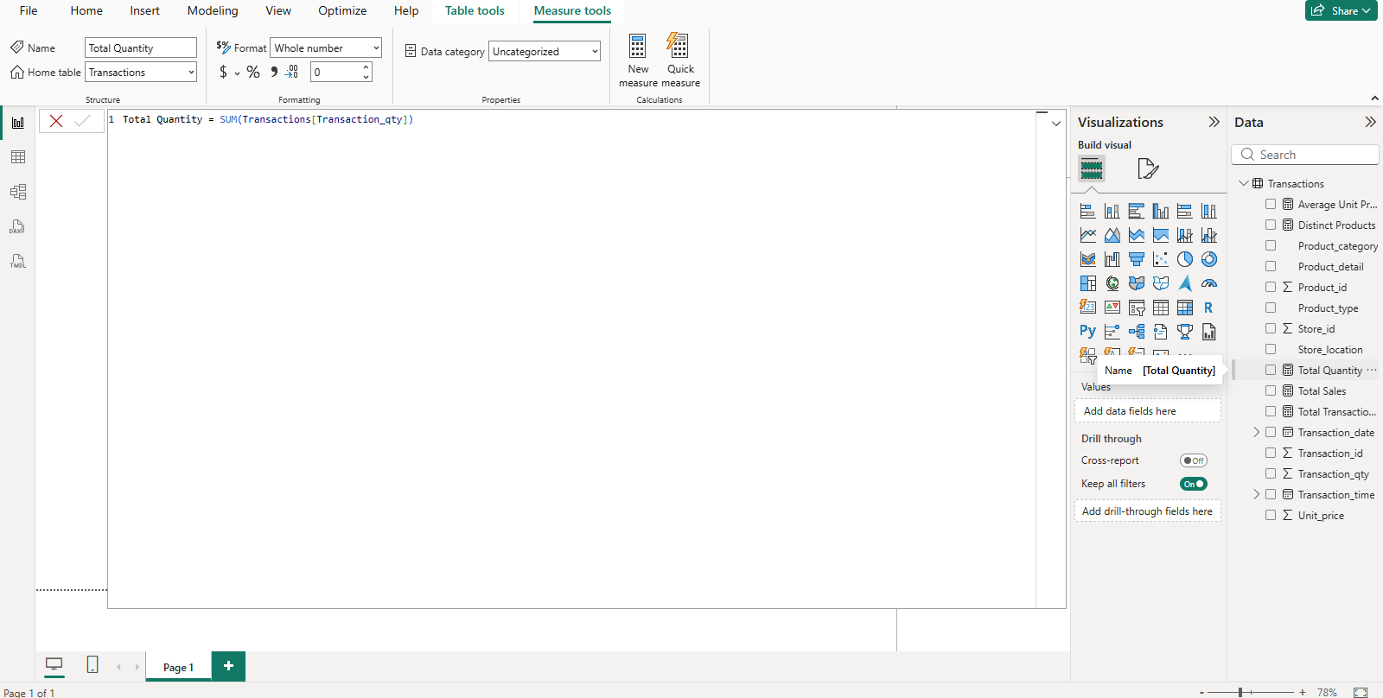

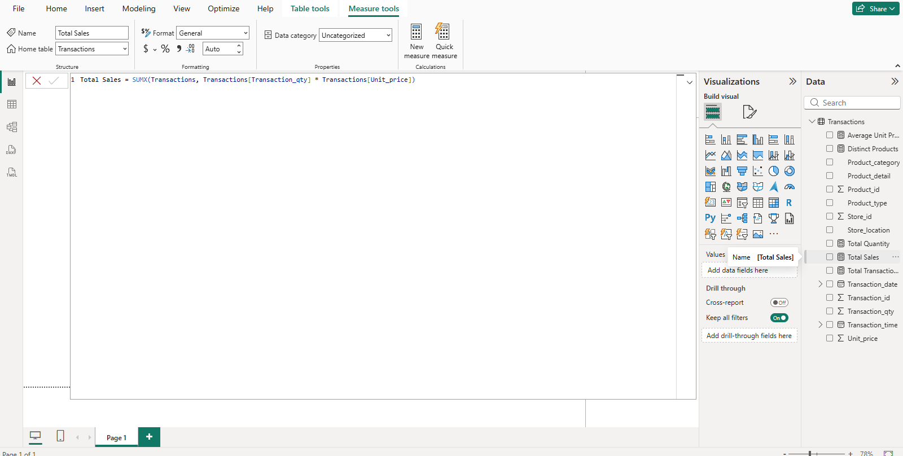

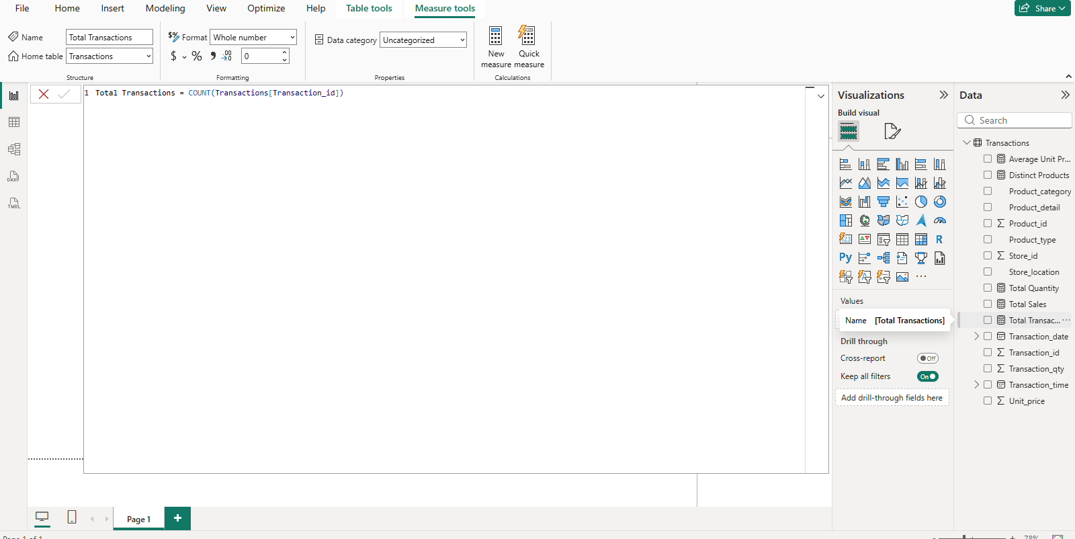

- Conclusion:
This dataset was successfully prepared for analysis in Power BI. Essential DAX Measure were created to calculate important business metrics. This provides a strong foundation for developing interactive dashboards and visual reports in the next stage of the project.

